Problem No: 05
Problem Name: Implement the Popular Image Enhancement Technique: Contrast Enhancement
Objective
- To understand the concept of contrast enhancement in digital images.
- To learn how contrast affects image quality and visibility.
- To implement contrast enhancement using Python.
- To improve image details by adjusting pixel intensity values.
- To gain practical knowledge of image enhancement techniques.
Theory: Contrast enhancement is an image processing technique used to improve the visibility of objects in an image by increasing the difference between dark and bright regions.
An image with low contrast appears dull because the pixel intensity values are concentrated within a small range. Contrast enhancement spreads the intensity values over a wider range, making image details clearer and sharper.
A common contrast enhancement formula is:
S=αR+βS
Where:
R = Original pixel value
S = Enhanced pixel value
α (alpha) = Contrast factor
β (beta) = Brightness adjustment factor
If α > 1, contrast increases.
If α < 1, contrast decreases.
Code:
from PIL import Image
import matplotlib.pyplot as plt
import numpy as np

img = Image.open("sm_pic.jpg")
img_array = np.array(img)
alpha = 1.5 # Contrast control
beta = 20 # Brightness control
contrast_img = np.clip(alpha * img_array + beta, 0, 255)
contrast_img = contrast_img.astype(np.uint8)
plt.figure(figsize=(10,5))

plt.subplot(1,2,1)
plt.imshow(img)
plt.title("Original Image")
plt.subplot(1,2,2)
plt.imshow(contrast_img)
plt.title("Contrast Enhanced Image")

print("Contrast Enhanced Image Matrix:\n")
print(contrast_img)
plt.show()
Output:
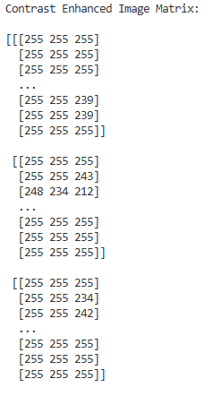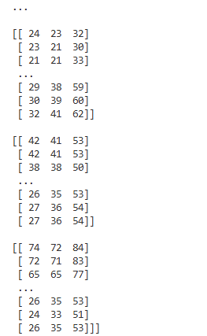
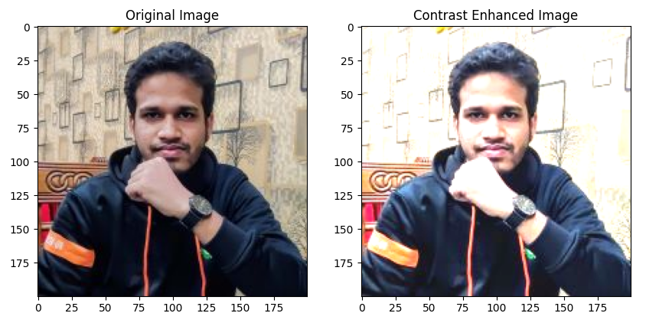
Result Discussion: The experiment successfully enhanced the contrast of the image. Dark regions became darker and bright regions became brighter, resulting in a clearer and sharper image. The enhancement improved image details and visibility significantly.
The output matrix showed that the pixel intensity values were modified according to the contrast enhancement formula.
Analysis: Contrast enhancement is an important technique in digital image processing. It improves image quality and helps reveal hidden details. Increasing contrast makes objects more distinguishable, especially in low-quality or poorly illuminated images.
However, excessive contrast enhancement may produce unrealistic images or cause loss of detail in extremely bright or dark regions.
Opinion: This experiment provided practical knowledge about image contrast manipulation and enhancement techniques. It helped in understanding how pixel intensity transformations improve image quality. The experiment is highly useful for applications in medical imaging, photography, and computer vision systems.

